FUSARIOSIS. A PROBLEM FOR THE WHOLE CHAIN: Farmers, traders, industrialists and consumers. Tolerances
---------------------------------------------------------------------------------------------------
Ing. Agr. Juan C. Batista. Asesor Técnico Comercial de CIS-Argentina SRL
With the collaboration of engineers Miguel A. López from Herbotecnia y Malvina Martínez from INTA Castelar
Fusariosis is a disease that occurs in many species of plants including grasses and is widely distributed on the planet. We can say that it is universal. It is present in all major producing regions. It is caused by the presence and development of several fungi of the genus Fusarium, whose origin can be the same soil (biota), the seed or a cross contamination from nearby plants. In wheat - and other winter grasses - it is known as "white blow" (head blight or scab in English) due to the pale yellow discoloration of the spikes and has particular interest given the importance of cultivation, the uses of its fruits (grains) and the impact on the health of people and animals.
Predisposing conditions for its development are soil moisture and basically high relative humidity and cloudiness in certain periods, mainly flowering and post-flowering.
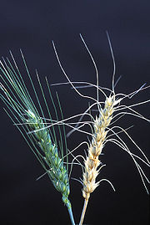
Image showing a healthy spike and another attacked by Fusarium sp.

Although, the fungus Fusarium sp. attacks various species of commercial importance such as grasses and nongramineae, namely: wheat, barley, rye, corn, tomato, potato, pepper, eggplant, banana, etc., in this article we will refer only to wheat and its impact on commercialization.
From the commercial point of view and its industrial use, the items with the presence of this fungus, usually have lower hectolitic weight and presence of toxins. These substances belong to the groups of fumonisins, trichothecenes and zearalenone. Of these groups, we will refer to trichothecenes, of which the most studied are: Nivalenol (NIV), Deoxinivalenol (DON), toxins T-2 and HT-2 and diacetoxyscirpenol (DAS). The most widespread in Argentina and Brazil is DON, presenting a medium toxicity. Toxins T-2 and HT-2 are up to 14 times more toxic than DON (commonly known as vomitoxin). The effects of these toxins usually occur quickly, approximately in 3 hours disappearing in 3 days. However, several fatal cases are reported. Perhaps the most significant is in the Soviet Union in the 1930s and 1940s when Fusarium contaminated wheat flour that was used to make bread and caused food poisoning with a 60% mortality rate.
In the USA and Canada, cases of destruction of whole wheat silos by contamination are reported.
In several ways the use of these toxins as a biological weapon has been commented on without being able to ensure their real use.
The active ingredient that was found was T-2 mycotoxin, which was produced in quantity and included in armament before the entry into force of the 1972 Biological Weapons Convention. The Soviets were accused of using this agent under the name of " Yellow rain "is presumed to have caused thousands of deaths in Laos, Cambodia and Afghanistan.
The most common symptoms in humans are skin, eye and throat irritation, gastrointestinal disorders and internal bleeding. Poisonings cause effects quickly after direct skin contact, inhalation or ingestion. In the case of populations of infants, elderly or immunocompromised, symptoms usually become more acute.
In animals, the most sensitive are pigs and those with the least impact are mammals, however, from a commercial point of view, a decrease in the rate of growth and fattening has been reported.
The predisposing conditions mentioned above and the inoculum already present in soils of several regions, cause large areas with fungus attack in certain campaigns, and in many cases, followed by medium to high levels of toxins. Although the correlation between grains attacked by the Fusarium fungus and toxin levels has been studied, being this low, there are generally lots with high presence of toxins and concomitantly, high level of damaged grains. These grains are characterized by being blackened, chuzos, are dry, pale or yellowish, light, with a gypsum endosperm and easily crumble under the pressure exerted on them. It is a defect considered in the marketing standards of Argentina (Res. 1262/2004 of the Ministry of Agriculture, Livestock, Fisheries and Food - Standard XX - paragraph 6.1.3.5) and of Brazil (MAPA-INSTRUÇÃO NORMATIVA No. 38/2010 ) that provide maximum tolerances.
In the photo, an analysis of an export sample with moderate presence of attacked grains and its comparison with good quality grains can be observed

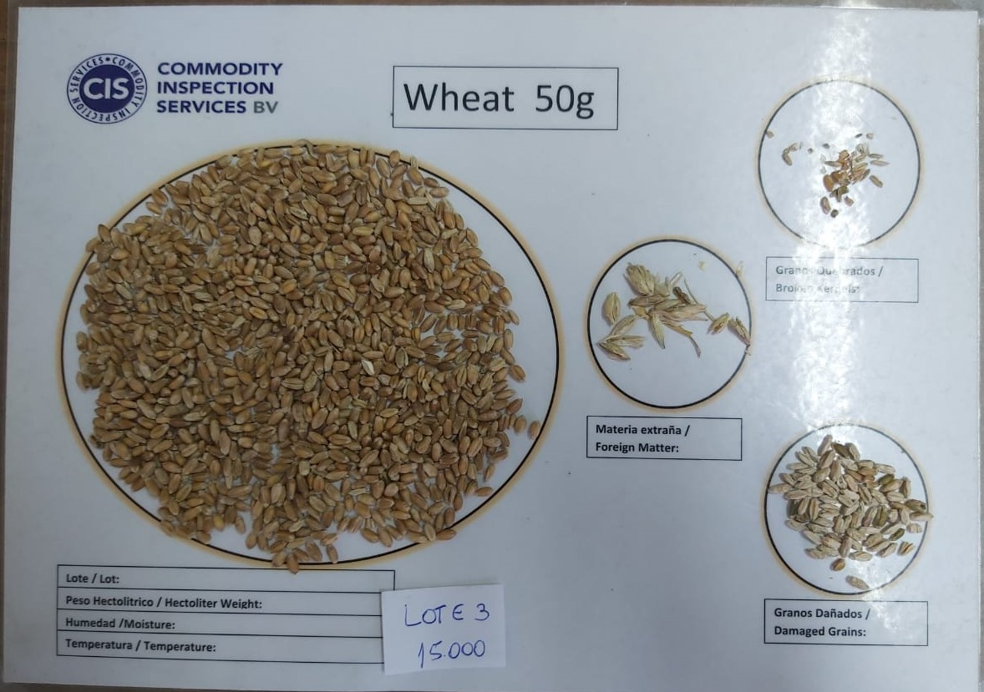

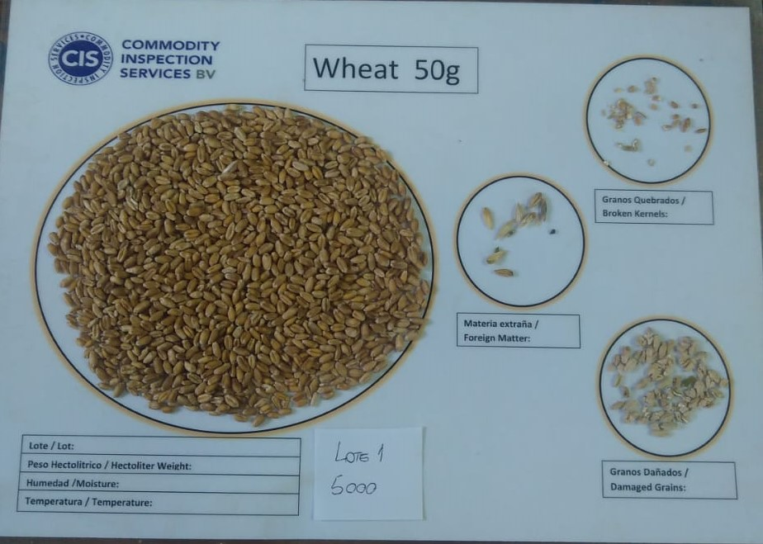
Several researchers have worked on the study of these fungi. But it is worth highlighting what was done by the INTA of Argentina, where a team of professionals has developed and perfected a predictive model of presence of defective grains based on certain climatic variables. For this purpose, a fusarium index has been constructed, subsequently a logistic regression with three levels of contamination (severe-moderate and zero) has been sought. Prediction alternatives on the presence of DON toxin have been developed.
This predictive model allows the farmer to take immediate or immediate preventive measures using various tools, both for next crops and for the current crop when it is in its critical stage and climatic conditions are predisposing.
The Institute of Climate and Water of INTA Castelar has developed forecast models, based on meteorological variables, to estimate levels of Fusarium and its associated mycotoxin (deoxinivalenol). These models allow the distribution of disease levels to be distributed before harvest and help in the definition of efficient wheat management strategies that enter, for example, a mill. The maps show the estimated levels of disease in grain samples based on their origin, that is, the environment to which the wheat lot was exposed during the susceptible period in that campaign.
Also, through the site http://agrometeorologia.inta.gob.ar/modeloenfermedad/ you can follow the evolution of the Fusarium Index of a particular site, selecting the weather station of interest and the date of appearance of the first spikes with exposed anthers (critical period). A graphical output will show the evolution of the disease.
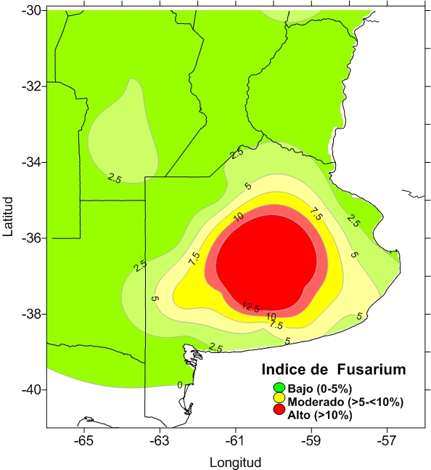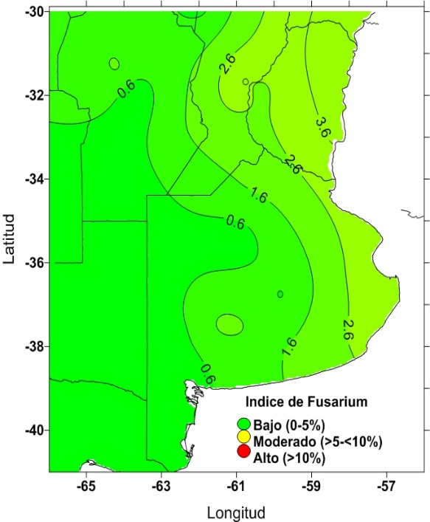
Figure. Annual Fusarium index for the 2018/19 wheat campaigns (left) and 2019/20 (right) for wheat with medium spike dates.
On the other hand, the collector, the cooperative and the flour mill, as well as the farmer who has conditioning facilities, can also use certain tools in order to mitigate the problem in the grain. The strategy of treatment of games with medium to high level of Fusarium can be based on the aspiration of the light grains, in cross ventilation applied to the inclined or vertical flow and shaking. The literature illustrates percentages of 30 to 70% decrease in grains attacked. This would most likely mean a significant decrease in the toxicity of the lot.
Several countries and international institutions have taken care of issuing recommendations and establishing acceptance levels for the presence of these toxins. Some have regulated their level for edible products, for flour or for wheat.
Below are some background:

PPB product (mg / kg)
Argentina
Flour, semolina, semolina and wheat flakes or flakes 1000

Brazil
Wheat and maize in grain 3000
Whole wheat and wheat bran- 1000
Wheat farinha, pastas, crackers, water cookies, and bread products- 750

Codex Alimentarius
Cereals in grain (wheat, corn and barley) intended for further processing 2,000
Flour, semolina, semolina and wheat, corn or barley flakes 1,000
Cereal-based foods for infants and young children 200
In this case, it is good to remember the document on CODE OF PRACTICE TO PREVENT AND REDUCE THE CONTAMINATION OF CEREALS BY MICOTOXINS CAC / RCP 51-2003, which was prepared with a broad international consensus.

European Union
Unprocessed cereals other than durum wheat, oats and corn 1.250
Unprocessed hard wheat and oats 1.750
Pasta (dry) 750
Bread and cereals for breakfast 500
Infant foods for infants and children 200
As in the previous case, the EU has the document for the prevention of mycotoxins EC Recommendation 2006/593

USA - United States of America (recommended limits)
Food for humans
Final wheat products 1 ppm

Animal feed -
Ruminants (meat) and cows> 4 months, and for hens for <50% diet 10 ppm
Pork for <20% diet 5 ppm
Other animals for <40% diet 5 ppm

As you can see, there is still no homogeneity about the criteria to apply for these cases. Science still does not have enough information to perform a solid Risk Analysis that allows establishing a certain level of tolerance.
On the one hand, the European Union often uses the so-called “precautionary principle” in a very strict or rigid manner and even, in some cases, at odds with the international principles agreed in the Sanitary and Phytosanitary Measures Treaty of the World Trade Organization. Many times, its legislation is not supported by solid scientific principles, which impacts on trade and the normal supply of basic foods.
Two examples have been the Panels on Hormones in Meats and on Genetically Modified Organisms, in both cases with clear demonstrations of being trade restrictive measures without scientific justification.
On the other hand, their disproportionate influence on the Committees of the Codex Alimentarius inclines the decisions of these bodies towards levels of recommendation that are difficult to reach, especially in these cases of mycotoxins, when it comes to contaminations of biological or climatic origins that are difficult or impossible to prevent. There are only some aspects or techniques for mitigating the presence of mycotoxins in grains, dilution by mixing cereal batches or destroying them.
That said, does not justify that the greatest efforts are not made for its mitigation and effective control, nor that sufficient precautionary measures are taken to prevent poisoning. It happens, particularly in this case of the DON toxin, which at low levels, its toxicity lies in the continuous consumption for long periods of intake, not having reported cases of acute intoxication at low levels, which should prioritize prudence and use of scientific criteria, since it is about food, which does not abound on the planet.
International grain trade has evolved in recent years towards mycotoxins as an increasingly important risk factor. Today it presents various types of agreements between buyers and sellers that provide for various limits, in many cases, even beyond those regulations by the health authorities of their countries.

